International Conference on Electrical, Electronics, and Optimization Techniques (ICEEOT) - 2016

**Real Time Voice Communication in Mobile Ad-**

|  |  |  |  |
| --- | --- | --- | --- |
|  | **Hoc Network** | |  |
| Emerson P | Ramkumar S Profun C J | | Subramanian P |
| Department of ECE | Department of ECE Department of ECE | | Department of ECE |
| Chennai-600123 | Chennai-600123 | Chennai-600123 | Chennai-600123 | |
| emerson.2389@gmail.com | raam.sampath@gmail.com | jesuprofun@gmail.com | subramanian0208@gmail.com | |

D.M.I College of D.M.I College of Engineering

Engineering

|  |  |
| --- | --- |
| D.M.I College of Engineering | D.M.I College of Engineering |

***Abstract--*** **A Mobile Ad hoc Network (MANET) is an accumulation of remote portable nodes framing a self-arranging system without utilizing any current base. We consider the issue of node situating in specially appointed systems. We propose an appropriated, framework free situating calculation that does not depend on GPS (Global Positioning System). Rather, the calculation utilizes a relative direction framework as a part of which the node positions are registered in two measurements. The fundamental commitment of this work is to characterize and register relative positions of the nodes in an impromptu system without utilizing GPS for constant voice correspondence. We facilitate clarify how the proposed methodology can be connected to wide range specially appointed systems. In Mobile Ad hoc system (MANETs), nodes versatility causes system topologies to change progressively after some time, which muddles critical errands, for example, TV and steering. Portability following is utilized to gauge the nodes area, with the goal that we can discover whether the node lies inside the scope zone or not for ongoing voice correspondence.**

***Keywords--Autoregressive (AR-1); Received Signal Strength Indicators (RSSI) and Time-Of-Arrival (TOA)***

I.AIM AND SCOPE OF THE PRESENT

INVESTIGATION

The primary commitment of this work is to characterize and figure relative positions of the nodes in an impromptu system without utilizing GPS. The future location of the destination can be computed as far as co-ordinates. Utilizing the destination location and source location we can ascertain the separation as far as meters. In the event that the separation is more than the scope region of the source node, it implies destination node lies out of scope region. Source node needs to move towards the destination node to make a continuous correspondence. We utilize location based forecast to gauge the future location of the nodes. In portable specially appointed systems (MANETs), nodes versatility cause system topologies to change progressively after some time, which entangles imperative assignments, for example, TV and directing. Portability following is the undertaking to decide a direction of the versatile node in time which can encourage the sending choice in system conventions' outline. A system is various PCs or gadgets that are associated with one another through physical or remote connections.

978-1-4673-9939-5/16/$31.00 ©2016 IEEE

A system is various PCs or gadgets that are associated with one another through physical or remote connections. An Ad Hoc system is a kind of neighborhood where every individual gadget in this system can speak specifically with some other gadget in a shared style. This game plan kills the contribution of a focal gadget that goes about as a base station or a switch. Impromptu systems work with the nonattendance of a settled base. The nodes in Ad Hoc systems can be has and switches which permits a message to be transmitted structure node to node through the system until it achieves its last destination. In the event of natural disaster like seismic tremor, surge, violent wind framework based correspondence will undoubtedly endure unsettling influence or absence of operability. Salvage or alleviation groups for the most part must be all around furnished with costly gear's to empower correspondence between people. Presentation of impromptu system based voice correspondence can fill well in this need. The node's portability greatly affects the execution and limit of versatile impromptu system. Much work on versatility administration has been done for the outline of directing conventions.

As a military driven examination range, versatile specially appointed systems (MANETs) rose to defeat the reliance on framework and give remote correspondence for all intents and purposes all around. Notwithstanding the inconsistent qualities of remote channels, the absence of foundation builds the effectively dynamic and hard to foresee conduct of portable remote interchanges. There is a requirement for circulated coordination among the system nodes, alongside element adjustment of the system conventions as channel Conditions change, with a specific end goal to beat the difficulties introduced by MANETs. With the expansion of convenient gadgets and additionally advance in remote correspondence, specially appointed systems administration is picking up significance with the expanding number of across the board applications.

II.RELATED WORKS

Location data is utilized to gauge the close time of the connection between two nearby has which decides the choice of course way. In [3] a diagram of existing portability expectation plans is given. Nonetheless, those expectations are likewise for connection accessibility and way unwavering quality estimation. Almost no work has been attempted to keep up an exact topology perspective to help the course way determination. There are two existing works: one is, the place a steady zone and an alert zone of every node have been characterized in light of a node's position, pace, and heading data acquired from GPS. In particular, a steady zone is the territory in which a versatile node can keep up a generally stable connection with its neighbor nodes. An alert zone is the range in which a node can keep up an insecure connection with its neighbor nodes.

Another is that Wu and Dai proposed a preservationist \two transmission range" strategy to repay the obsolete topology nearby view[5]. In any case, all of above methodologies are latent since they simply attempt to repay the mistake of the system topology see as opposed to foresee portable nodes' positions (versatility following) to build a system topology view in time. Few versatility following for MANETs has been finished. One existing work is Zaidi et al.. A first-arrange autoregressive (AR-1) model is utilized as portability model. Every node utilizes a stretched out Kalman channel to gauge its own portability state by joining system based sign estimations, for example, got signal quality pointers (RSSI) and time-of-entry (TOA), and the position assessments of the neighbor nodes. The issue of their work depends on exceptional AR-1 display instead of broadly utilized versatility models, which is not suitable to help the outline of system convention. Each foundation based voice correspondence framework (GSM, CDMA and so forth) is driven by incorporated structures such as Base

Station/MTSO and so forth. Which are restricted in limit and can accommodate some measurably normal burden. At the point when a tremendous social event happens, as in a football match or show or some parade they pitiably neglect to bolster voice correspondence. In such a compelling cases, impromptu system can give valuable substitute method for correspondence between individuals.

1. *Location Prediction*

We proposed portability tracking schemes to predict nodes' directions. Nonetheless, there exist a few conceivable imprecision elements: GPS perusing got may not generally be precise because of different reasons (e.g., multi-path fading, indoor conditions, etc.). In this present reality, these components cause anticipated directions erroneous. Utilizing nearby facilitate framework we can ascertain precisely. In

section 3 we can see intricately about location prediction

1. *Forward Decisions*

Forward choices taking into account obsolete system topology perspective might be wrong and subsequently cause conveyance disappointment which can prompt poor scope of show assignment or course disappointments. The left a portion of Fig.2 speaks to the perspective of node i, and right part is the genuine physical topology. In view of a mistaken neighborhood view, node i chooses forward nodes k and l and allots forward nodes' transmission spans. Be that as it may, in genuine physical topology, node l moves out of the transmission scope of i and can't get the message and forward it. On the off chance that the elements of the system topology could be anticipated ahead of time, proper forward choice can be made with a specific end goal to stay away from or lessen conveyance disappointments. Subsequent to the nodes are versatile, the system topology might change quickly and capriciously and the availability among the terminals might shift with time. MANET ought to adjust to the activity and engendering conditions and in addition the portability examples of the versatile system nodes. The portable nodes in the system powerfully build up steering among themselves as they move about, shaping their own system on the fly.

In MANET, every versatile terminal is a self-ruling node, which might work as both a host and a switch. In other, since there is no foundation system words, other than the essential preparing capacity as a host, the portable nodes can likewise perform exchanging capacities as a switch. So generally endpoints and switches are undefined in MANET. It permits the gadgets to keep up associations with the system and also effortlessly including and evacuating gadgets in the system. In specially appointed systems, the system topology elements can be construed from the versatility of the nodes. Versatility following is the undertaking to decide a direction of the portable nodes position in time. In this manner, it could be of noteworthy advantage to the configuration of system conventions. We utilize here proactive portability administration arrangements, versatility expectation, to address the above obsolete perspective issues. We propose both piecewise direct which make utilization of node's authentic data to foresee a direction of the versatile node position

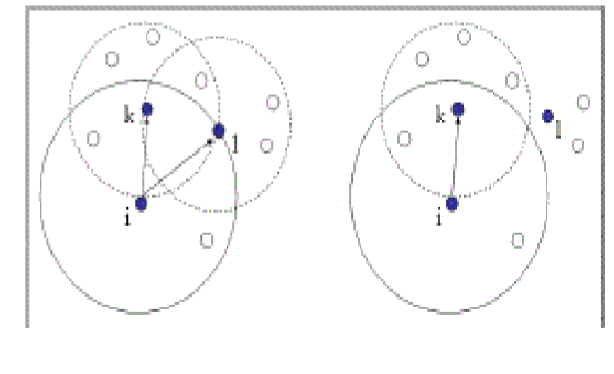

Fig 1. Impact of outdated topology view on delivery

III.PROPOSED ALGORITHM

In this section we present local coordinate and then propose mobility tracking schemes based on historical information extracted from updates. In local coordinate scheme each node can build its coordinate. In the location prediction scheme future location of the node can be calculated.

* To build local coordinate system
* Location based prediction
* The overall algorithm

*A. To Build Local Coordinate System:*

Here local coordinate system can be calculated by assuming source node lies at origin ݔሺ௛,ݕ௛) and direction ሺ݀௫,݀୷). Now source node shares its information with its one hop neighbor node at time ݐ௛. One hop neighbor node receives at time ݐ௖. Now the one hop neighbor node builds local coordinate using this information. Then local coordinate

(ݔ௘;ݕ௘) at ݐ௖ can be calculated as

ݔ௘= ݔ௛ + (ݐ௖- ݐ௛).݀௫ (1) ݕ௘ =ݕ௛ + (ݐ௖- ݐ௛).݀୷ (2)

Each node’s local coordinates can be build using the above formula to build its coordinates. In figure 2 shows i.e each node builds its coordinates by sharing their information to its one hop neighbor node so each node in the environment can build its coordinates.

Fig 2.Builds the relativ

e coordinate system

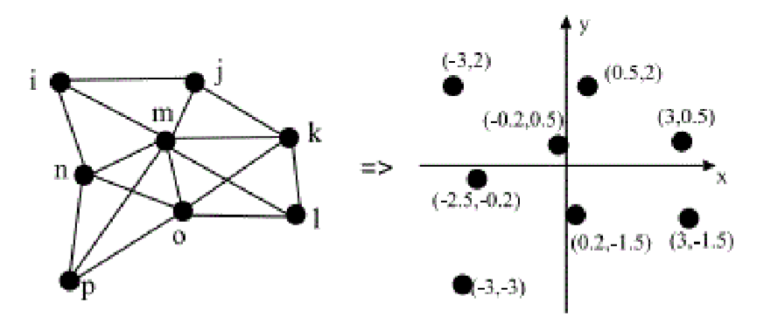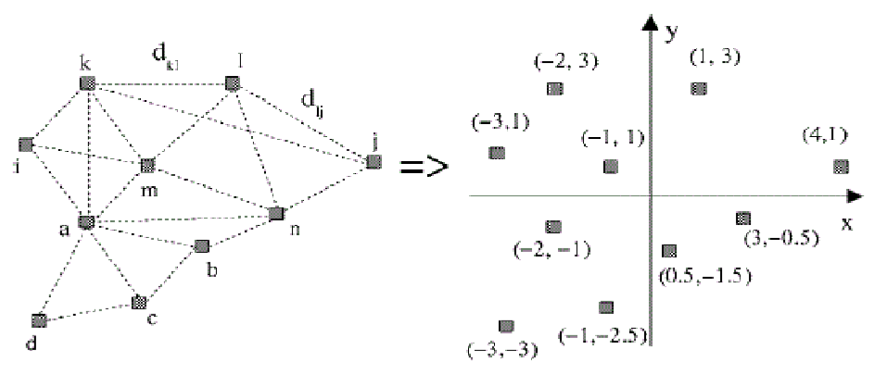

*B. Location Based Prediction*

Suppose that there are two latest updates records for a

particular node respectively at time  with location information of (ݔଶ௛,ݕଶ௛) and (ݔଵ௛,ݕଵ௛). Assume at least within two successive update periods the node moves

in a straight line with fixed speed (depicted in Fig 3.).we get

௫ మ೓ష௫భ೓ = ௫೎ష௫భ೓ (3)



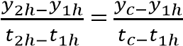 (4)

Then the location Then the location (ݔ௖,ݕ௖) at a future time ݐ௖ can be calculated as

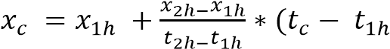) (5) 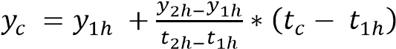 (6)

The future location of the destination node (ݔ௖,ݕ௖), the location of source node (ݔ௘;ݕ௘) are known. Now using distance calculation we can find the distance between the source and destination in terms of meters (m).

 (7)

Each node has a coverage of 250m (Į=250m) if the distance value is less than the coverage means destination lies inside the coverage of source node here the communication is interactive (real time communication). If the distance value is more than the coverage means the destination node lies out of coverage of source node. So source node has to move towards the destination node linearly to make real time communication.

> Į (8)

*C. The Overall Algorithm*

*Step1*: Source node coordinates be (ݔ௛,ݕ௛) and direction (݀௫,݀୷). Source node lies at origin.

*Step2:* Source node shares this information with its one hop neighbor node at time ݐ௛.

*Step3:* Then local coordinate of one hop neighbor node

(ݔ௘;ݕ) at ݐ௖ can be calculated as

ݔ௘=  + (ݐ௖- ).݀௫ (9) ݕ௘ =ݕ௛ + (ݐ௖- ).݀୷ (10)

*Step4:* Each node builds its coordinate system accordingly. *Step5:* Two latest updates of particular node is taken respectively at time ݐଶ௛ and ݐଵ௛ (ݐଶ௛<ݐଵ௛ ) with location information of (ݔଶ௛,ݕଶ௛) and (ݔଵ௛,ݕଵ௛).

Step6: Then the future location (ݔ௖,ݕ) at a future time ݐ௖ can be calculated as,

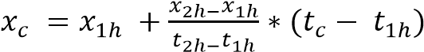 (11)

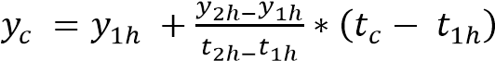 (12) *Step7:* Now we have source and destination coordinates using distance formula we can calculate the distance between the source and destination in terms of meter (m).

(13)

݀

ൌ

ඥ

ݔሺ

௘

ݔെ

௖

ሻ

ଶ

ݕሺെ

௘

ݕെ

௖

ሻ

ଶ

*Step8:* If the distance value is less than the coverage area (Į), it means the destination node lies inside the coverage area of source node. So communication will be real time. Step9: If the distance value is greater than the coverage area (Į), it means the destination node lies out of coverage area, so source node has to move towards the destination.

Table 1. Mobility Tracking Simulation

|  |  |
| --- | --- |
| **Parameters** | **Values** |
| Simulation network size | 900 × 900 m2 |
| Mobile nodes speed range | [0, 15] m/s |
| Simulation time | 150 s |
| Location record | 2 s |
| Prediction interval 20 ms | 20 ms |
| Conditional update | 5m |
| Movement Model | Linear |
| Antenna model | Omni Antenna |
| Number of nodes | 10 |
| Routing Protocol | AODV |
|  |  |

*Fig4. Estimated location output*

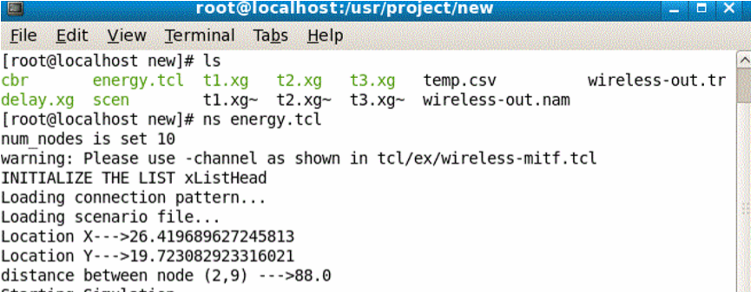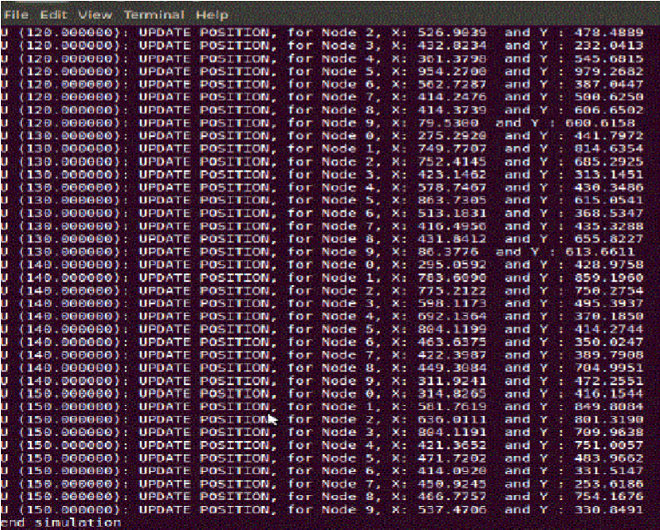

Fig 5. TCL and Trace file for the Scenario at 50sec

The above figure shows the location of 10 nodes.It also displayed the updated position for each of the node with their

X and Y coordinates details



Fig 6. TCL and Trace file for the Scenario at 150sec

The above figure shows the location of 10 nodes .It also displayed the updated position for each of the node with their

X and Y coordinates details

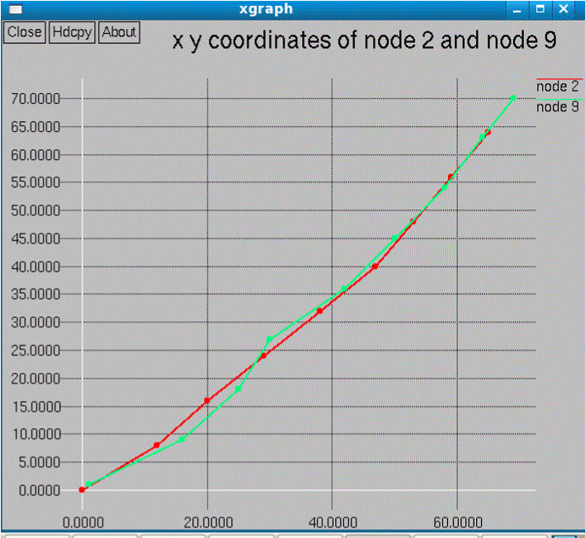

Fig 7. (x,y) coordinates of node 2 and node 9Fig7. represents distance between node 2 and node 9. Here the distance is 270 meter which is greater than Į (coverage area 250m). It means the node 9 lies node lies out of coverage area. So source node cannot communicate with its destination. In order to make it as real time communication source node has to move towards its destination.

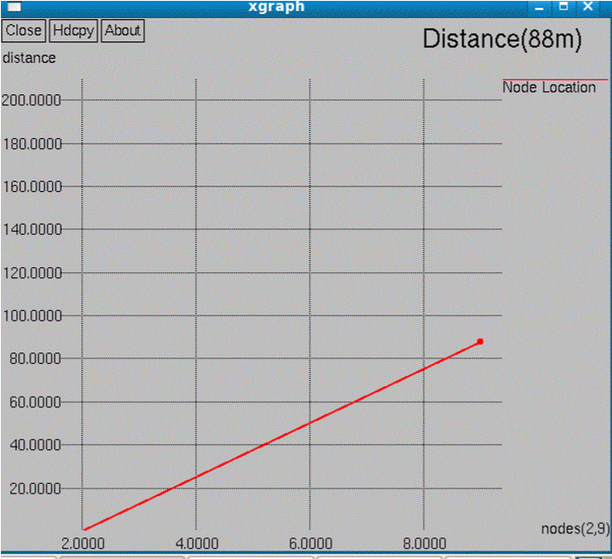

Fig 8.Distance between Node 2 and Node 9 (<ǹ)

Fig8.Represents distance between node 2 and node 9. Here the distance is 88 meter which is less than Į (coverage area 250m). It means the node 9 lies inside the coverage of node 2. So source node can communicate with its destination. Here the communication will be real time because nodes lie inside the coverage area

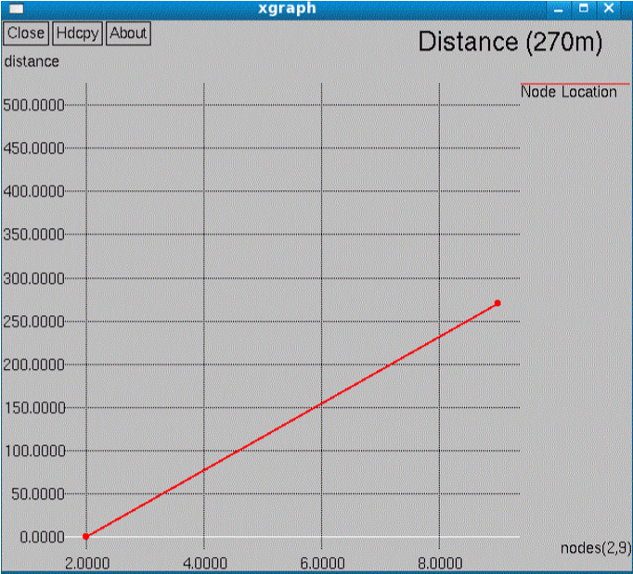

Fig 9.Distance between node 2 and node 9 (>Į)

IV.SUMMARY

In this paper we abridged the thought of GPS free situating strategy and demonstrated the execution yield achievable by utilizing nearby organizes framework. Specially appointed system is a rising field in systems administration enclosure. Transmission of voice over such system makes it more relevant in certifiable. In this paper, we depict a calculation for the situating of nodes in a specially appointed system that does not utilize GPS. The calculation gives position data to the nodes in the situations where a framework does not exist and GPS can't be utilized. Sans gps situating is likewise alluring, when the GPS sign is excessively feeble (e.g., indoor), when it is stuck, or when a GPS collector must be kept away from for expense or reconciliation reasons. The nodes in the impromptu systems are typically not mindful of their geological positions. As GPS is not utilized as a part of our calculation, we give relative positions of the nodes concerning the system topology. For the purpose of effortlessness, we show the calculation in two measurements this thought can be utilized as a part of instance of any Emergency administrations Search and protect operations, Disaster recuperation Replacement of altered base if there should arise an occurrence of natural calamities.

V. CONCLUSION

In this paper, we proposed linear mobility tracking schemes to predict nodes trajectory for real time voice communication. Our prediction schemes are based on historical information achieved through periodic updates.

Our algorithm uses GPS free positioning it does not rely on GPS device. The algorithm provides position information to the nodes in the scenarios where an infrastructure does not exist and GPS cannot be used. GPS-free positioning is also desirable, when the GPS signal is too weak (e.g., indoor), when it is jammed, or when a GPS receiver has to be avoided for cost or integration reasons. Our main contribution of this work is to define and compute relative positions of the nodes in an ad hoc network without using GPS for real time voice communication.

REFERENCES

1. T. Camp (eds.), “A Survey of Mobility Models for Ad Hoc Network Research,” Wireless Comm. and Mobile Computing, special issue on mobile ad hoc Networking: research, trends and applications, Vol 2-No. 5(2002) pp.483-502.
2. J. Zhang, J. P. Yu, S. W. Zhou, Y. P. Lin, and G. Li, “A survey on position-based routing algorithms in wireless sensor networks Algorithms,” Vol. 2, Academic, 2009, pp.158-182.
3. R. Chellappa Doss, A. Jennings, N. Shenoy: “A Review Of Current Mobility Prediction Techniques For Ad Hoc Networks,” in The 4th  IASTED International Multi-Conference Wireless and Optical Communication Banff, Canada (2004),pp. 536-542
4. W. Su, SJ. Lee, M. Gerla, “Mobility Prediction and Routing in Ad Hoc Wireless Networks,”- International J. Network Management, Vol. 11, No. 1 (2009) pp.3-30
5. J. Wu, F. Dai,”Mobility Control and Its Applications in Mobile Ad Hoc Networks” -Handbook of Algorithms for Wireless Networking and Mobile Computing, Academic, 2006 pp. 22-501-22-518
6. T. Camp, J. Boleng, B. Williams, L. Wilcox, and W. Navidi, “Performance evaluation of two location based routing protocols,” in Proceedings-The Joint Conference of the IEEE Computer and Communications Societies (INFOCOM) pp. 1678-1687, Academic, 2002
7. Samarth H. Shah, Klara Nahrstedt, “Predictive location-based QoS routing in mobile ad hoc networks,” -IEEE International Conference on Communications,New York, USA.
8. J. Broch, D. Maltz, D. Johnson, Y. Hu, and J.Jetcheva,” Multi-hop wireless ad hoc network routing protocol,” In Proceedings - the ACM/IEEE International Conference on Mobile Computing and Networking (MOBICOM), pp.85-97,1998.
9. W.I.Kim, D. H. Kwon, Y. J. Suh:,”A reliable route selection algorithm using local positioning systems in mobile ad hoc networks,” -The IEEE International Conference om Communication, Amsterdam, USA, Academic, 2001.
10. K. Fall, K. Varadhan:” The ns Manual,” in -The VINT Project, UCB, LBL, USC/ISI and Xerox Parc- Academic,(2002)
11. Zainab R. Zaidi, Brian L. Mar, “A Distributed Mobility Tracking Scheme for Ad Hoc Networks Based on an Autoregressive Model,” in the 6th International Workshop of Distributed Computing, Kolkata, India (2004) pp.447
12. S.C apkun, M. Hamdi, and J. P. Nodeaux, “GPS-free positioning in mobile ad-hoc networks”, in Proceedings of The 34th Hawaii International

Conference on System Sciencea, Academic, 2001,Vol. 9, pp. 1-10

1. M. Grossglauser, D.Tse,”Mobility Increases the Capacity of Ad-Hoc Wireless Networks,” in IEEE Infocom, Alaska, USA (2006)

14] N. Bulusu, J. Heidemann, and D. Estrin, “GPS-less low-cost outdoor localization for very small devices,” -IEEE Personal Communications, pp28–34, October 2000.

[15] D. Camara and A.Loureiro: “A novel routing algorithm for ad hoc networks,” in Proceedings of the 33rd Hawaii International Conference on System Science, Vol.8, pp.1-8, 2000.